**Low Cost Expendable Buoys for Under Ice Data Collection**

Daniel Langis, Phyllis Stabeno, Calvin Mordy, Chris Meinig, Jessica Cross, Heather Tabisola

Conditions just under Arctic sea ice during Spring and early Summer months are largely a mystery, but we do know they play a critical role in shaping one of the world’s most highly productive ecosystems. Massive phytoplankton blooms have also been identified under Arctic Sea Ice, but the prevalence of such events and their impact on ocean ecology and carbon fixation is unknown. However, broad inaccessibility due to harsh and unpredictable conditions makes data collection under sea ice notoriously difficult.

PMEL has designed a new low-cost expendable under-ice instrument, capable of collecting oceanographic data at the water-ice boundary to help address gaps in knowledge during these vital periods. These instruments are designed to be deployed from a vessel during the ice-free season, whereupon they remain anchored on the bottom for many months until the surface is covered in sea ice. At a designated time for each device, the instruments release from their anchors and collect a vertical profile of the water column and rest just under the ice. The buoys remain under ice until they are forced out by break-up and melting, transmitting their data to shore via satellite when they arrive at the surface.

Preliminary versions of the instrument were deployed in the Chukchi Sea in 2015 (Gen 1) and Bering Sea in 2017 (Gen 2), collecting data on temperature, depth, and Photosynthetically Active Radiation (PAR). These deployments have successfully demonstrated the viability of the low-cost design, its robust nature, and its ability to provide high-quality data. The newest version of the buoy (Gen 3) will also measure fluorescence and collect daily images to assess water color. Onboard GPS provides precise location data once at the surface and all data are transmitted to shore using Iridium Short Burst Data.

One of the most critical elements of the project has been driving down the cost of each buoy at every level. Low-cost pressure housings, sensors, electronics, and materials all needed to be integrated without sacrificing performance in order to make this a viable technology. These compact instruments are optimized for use in the relatively shallow waters of the Arctic continental shelf. Cost advantages can be best leveraged to provide improved spatial coverage over this enormous area, where observations are typically few and far between.

Opportunities for future development such as providing sea surface temperature when in open water and expanding the sensor suite are currently being explored.

This project has been funded by Pacific Marine Environmental Lab’s Innovative Technology for Arctic Exploration program with in-kind support from Ecosystems and Fisheries Oceanography Coordinated Investigations.

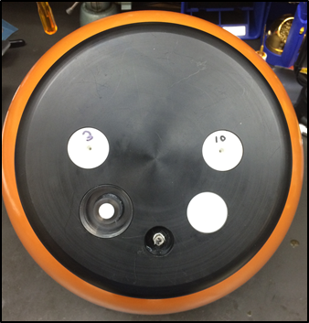

*Figure 1: Top View of Under-Ice Buoy (Gen 2) showing PAR, Depth, and Temperature Sensors.*

*GPS and Iridium Antennas are embedded under the cap to prevent them from being damaged by ice.*

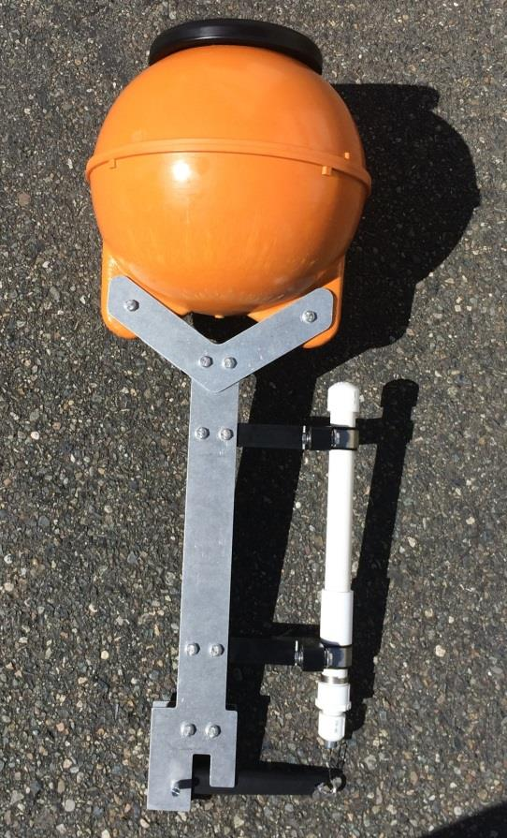

*Figure 2: Side View of Under-Ice Buoy (Gen 2) showing pressure housing and release mechanism.*

*Height from top of buoy to bottom of frame: 90 cm*